Being a Governor at The Royal Marsden

The Council of Governors
Members of The Royal Marsden vote in the elections for the member they would like to join the Council of Governors as their Patient/Carer/Public/or Staff Governor representative. Local stakeholders such as Clinical Commissioning Groups, Local Authorities and our academic partner The Institute of Cancer Research are also represented. The Council of Governors are not responsible for the performance and management of the Trust as this is the responsibility of the Board of Directors.

The diagram below outlines the structure of the Council:
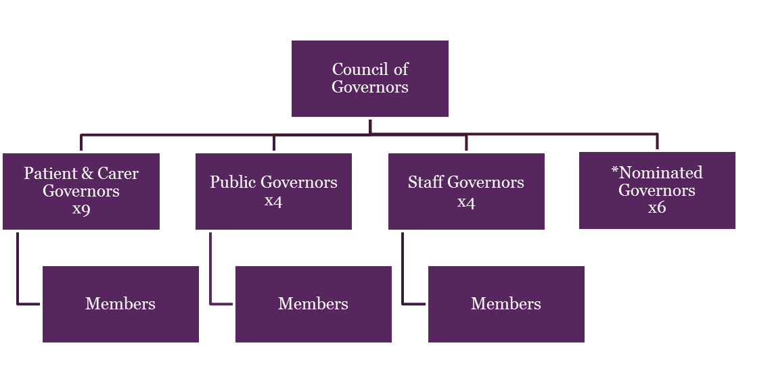 *Appointed representatives from key stakeholders

Composition of the Council of Governors
Type of Governor | Constituency Class/Area | N0. of Seats
Patient | Kensington & Chelsea and Sutton & Merton  Elsewhere in London  Elsewhere in England | 3  2  2
Carers | Carer | 2
Public | Kensington and Chelsea  Sutton and Merton  Elsewhere in England | 1  1  2
Staff | Doctor  Nurse  Corporate and Support Services  Clinical Professionals | 1  1  1  1
Nominated | The Institute of Cancer Research  Cancer Research UK (Charity)  Local Authority: Royal Borough of Kensington and Chelsea  Local Authority: Boroughs of Sutton and Merton  West London Clinical Commissioning Group  Sutton Clinical Commissioning Group | 1  1  1  1  1  1

The Role of the Governor
Governors play an important role in the governance framework of the Trust. The main way in which they do this is by attending the quarterly Council of Governors meetings, where they advise and help support the Trust Board and senior management to understand the needs of its patients, carers and local community. It is important to note that Governors are volunteers; they are not directors nor do they form part of the management of the Trust.

There are a number of statutory roles and responsibilities for Governors set out under the
National Health Service Act 2006 and the amended Health and Social Care Act 2012. These are defined as:
- Appoint and, if appropriate, remove the chair;
- Appoint and, if appropriate, remove the other non-executive directors;
- Decide the remuneration and allowances and other terms and conditions of office of the chair and the other non-executive directors;
- Approve (or not) any new appointment of a chief executive;
- Appoint and, if appropriate, remove the NHS foundation trust’s auditor; and
- Receive the NHS foundation trust’s annual accounts, any report of the auditor on them, and the annual report at a general meeting of the council of governors.
- Hold the non-executive directors, individually and collectively, to account for the performance of the board of directors;
- Represent the interests of the members of the trust as a whole and the interest of the public;
- Approve “significant transactions” (if defined by the Constitution);
- Approve an application by the trust to enter into a merger, acquisition, separation or dissolution;
- Decide whether the trust’s non-NHS work would significantly interfere with its principal purpose, which is to provide goods and services for the health service in England, or performing its other functions;
- Approve amendments to the Trust’s Constitution.

Frequently Asked Questions
Who can become a Governor?
Anyone who is a member of The Royal Marsden NHS Foundation Trust can become a Governor of their constituency. You do not need to have any particular knowledge, qualifications or experience, just be enthusiastic and committed to helping The Royal Marsden. It would be useful if you enjoy communicating with people and are comfortable in meetings, but you will be provided with training, information and support to enable you to develop the knowledge and skills required for the role.

The Trust is committed to have representation from all sections of society and would welcome and support applicants from minority groups which are traditionally under represented.

A person cannot become a Governor if:
- he/she has been adjudged bankrupt or his estate has been confiscated and in either case he/she has not been discharged;
- he/she has made a composition or arrangement with or granted a trust deed for his/her creditors and has not been discharged in respect of it;
- he/she has within the preceding five years been convicted in the British Islands of any offence, and a sentence of imprisonment for a period of three months or more was imposed upon him;
- he/she is an Executive or Non-Executive Director of the Trust, or a Governor, Non-Executive Director, Chairman or Chief Executive Officer of another NHS Foundation Trust (unless they are appointed by an appointing organisation which is a health service body);
- he/she has ever been or is currently involved in a claim against the Trust;
- he/she a person who has demonstrated aggressive or violent behaviour or behaviour that at the Trust’s absolute discretion is considered inappropriate; at any hospital operated by The Royal Marsden NHS Foundation Trust and following such behaviour has been asked to leave, been removed, or excluded from any such hospital or other healthcare facility in accordance with the Trust’s policy for withholding treatment from violent/aggressive patients;
- he/she is considered a vexatious complainant by the Trust, in accordance with the Trust’s policy for handling complaints;
- he/she is on the Sex Offenders’ Register;
- he/she excluded by any other provision detailed within the Trust’s constitution. The constitution is available at the following link: https://www.royalmarsden.nhs.uk/about-royal-marsden/how-we-run-ourselves/council-governors/governor-elections

What does being a Governor involve?
Governors are required to attend five formal Council of Governors meetings per year, including the Annual General Meeting. Should Governors want to become more involved, there are working groups and committees they can become members of however, this is optional and subject to capacity on the groups and committees.

An annual Governor training day is held, Governor seminars, Members’ events and Members’ week which may total a further 3-5 days over the course of a year. Where possible, meetings will be scheduled on the same day.

Governors are encouraged to attend and support our Members’ events and annual Members’ week as well as put forward ideas on how the Trust can recruit and engage with members of the Trust through the Membership and Communications Group a working group of the Council of Governors.

On appointment new Governors will be expected to attend induction meetings with the Chairman and Company Secretary.

When and where are meetings held?
Currently all meetings are held virtually as a result of Covid-19. When restrictions are eased and face to face meetings resume the majority of these meetings will take place at the Chelsea site and are held during normal business working hours, although we try to avoid early morning start times to allow sufficient travel time. The Council of Governor meetings start at 11am and finish at 1pm. Reimbursements of travel and carer expenses are paid in accordance with Trust policies and procedures.

I’d like to get involved, but I’m not used to formal meetings – is this for me?
We recognise that formal meetings can sometimes feel intimidating if you are not used to them. The Corporate Governance office will support and help you to find an effective way for you to contribute if you are not comfortable speaking in meetings.

How do I apply?
When there is a vacancy for a Governor position, we write to all eligible members to ask if they would like to stand as a Governor. Interested candidates are asked to complete a nomination form, including a short statement explaining why they would like to be a Governor.

Members will then vote for the Governor they choose to represent them based on the short statement provided by each candidate. Please contact us if you have any queries on the nomination form. Your home address and contact details will remain confidential.

If elected, how long can I serve as a Governor?
Governors hold a term of office for three years and may stand for re-election up to three times but cannot hold office for longer than nine years.

If you have any questions or require and further information, please contact
Rebecca Hudson, Membership Manager, who will be happy to assist you.
Tel. 0207 808 2844
Email: Rebecca.hudson@rmh.nhs.uk

