|  |
| --- |
| Workforce Race Equality Standard 2019 |
| July 2019 |
|  |

# Background and introduction

# This report provides the 2019 Workforce Race Equality Standard (WRES) findings for the Royal Marsden NHS Foundation Trust, identified progress made towards the 2018/2019WRES action plans and outlines the WRES priorities for 2019/2020.

# The WRES was designed to improve the representation and experience of Black and Minority Ethnic (BME) staff at all levels of the NHS and establish systematic monitoring of race equality performance. Since 2015 all NHS organisations have been required to publish data against the nine WRES indicators as at the 31st March each year and to develop and publish a report and action plan that is based on the WRES findings to address any differences identified.

# The WRES has been built into assurance and regulatory processes including the Care Quality Commissions inspections and the NHS standard operating contract.

# 2019 Workforce Race Equality Standard findings

There are nine WRES indicators, four of the indicators focus on workforce data (indicators 1-4), four on findings from the annual staff survey (indicators 5-8) and one indicator focusses on BME representation on Boards (indicator 9).

More information about the nine indicators and 2019 WRES findings are provided in appendix 1.

The total number of staff employed within The Royal Marsden NHS Foundation Trust at 31st March 2019 was 4350. Of these the proportion of BME staff employed was 1419 staff (32.6%) with 98.4% of all staff disclosing their ethnicity

The key findings from the 2019 data are:

* An increasingly proportionate workforce composition of communities served but not an even distribution across all grades particularly at senior level - see appendix 2 (indicator 1)
* An improvement in the likelihood of White staff being appointed from shortlisting compared with BME staff. In 2019 White staff were 1.65 times more likely to be appointed from shortlisting compared with 2.08 times more likely in 2018 (indicator 2)
* A slight deterioration in the likelihood of BME staff entering the disciplinary process compared with White staff - 2.07 times more likely in 2019 compared with 2.01 times more likely in 2018. Overall however the 2019 finding is an improvement on the 2015 baseline year that found BME staff 2.44 times more likely to enter the disciplinary process (indicator 3)
* Proportionately equitable access to non-mandatory training and continuous professional development (CPD) for BME and White staff is noted since 2017 when this indicator was redefined (indicator 4)
* An increase in the proportion of BME staff experiencing harassment, bullying or abuse from patients in the national staff survey, although an improvement is noted for this finding since the baseline year of 2015 (indicator 5)
* An increase in the proportion of BME staff experiencing harassment, bullying or abuse from staff in the national staff survey which is the same finding as the baseline year 2015 (indicator 6)
* A decrease in the proportion of BME staff believing the Trust provides equal opportunities for career progression or promotion in the national staff survey, although the 2019 findings are a 4% point improvement on the 2015 baseline finding for this indicator (indicator 7)
* An increase in the proportion of BME staff experiencing discrimination from their manager/ team leader or colleagues in the national staff survey, however this is an 8% point improvement since 2015 (indicator 8)
* The change in the Board diversity difference reflects the impact of an improvement in the ethnic composition of the Board and the increasing proportion of BME staff employed - -25% in 2019 compared with -30.5% in 2018 (indicator 9)

**Note:** data for indicators 1 and 9 is as at 31 March 2019, indicators 2 and 4 is from the period 1 March 2018 to 31 March 2019, indicator 3 is from the period 1 April 2017 to 31 March 2019 and data for indicators 5 – 8 is taken from the national staff survey findings

# Review of 2018-2019 WRES action plan

Actions were agreed by the Equality, Diversity and Inclusion Steering Group in 2018 to maintain and improve performance against the WRES indicators and a review of these is outlined below:

1. **Board representation**

The Trust now works with recruitment and Executive search agencies who guarantee to provide a diverse selection of candidates for Board and Leadership roles.

1. **Leadership development**

* The Academic Health Science Centre (AHSC) leadership programme was redesigned to include a module for participants on inclusive leadership. The AHSC is an NHS/ University partnership of which we are a partner.
* The Careers Advisory Service was launched with interview skills workshops available to all staff.
* The Career Development Mentoring Scheme was expanded to staff in Bands 1-7 and a Career Coaching Scheme was launched to all staff. Increased promotion is required to raise awareness of these schemes.
* As part of the launch of the new values and behavioural framework, appraisal documentation has been revised and includes short, medium and longer term career focus as part of appraisal discussion.
* There has been wide promotion of leadership development opportunities to staff through internal communication mechanisms including weekly bulletin, intranet and through the BAME staff forum.
* The chair of the BAME staff forum was sponsored on the NHS WRES Experts programme and members of staff have been sponsored on the Stepping Up leadership development programmes.
* All Chairs of the staff equality networks have become regular members of the Board level Equality Diversity and Inclusion Steering Group.

1. **Reducing variation of BME staff entering disciplinary process**

* The disciplinary policy has been updated and the Employee Relations Team continues to use the disciplinary checklist in their discussions with managers about potential disciplinary cases. Two decision making matrixes are now; one to determine whether a case should go forward to formal investigation and the second for determining hearing outcomes.
* Participated in the pan-London WRES indicator 3 project to reduce the number of BME staff who are disciplined compared to white staff across London.

1. **Organisation development**

* Through our Outstanding Care, Outstanding Culture programme, staff and patients were involved in the refreshing of our organisational values and in the defining of positive behaviours associated with these. One of the new values is Working Collaboratively which embeds inclusive and positive behaviours for working together and reducing inappropriate behaviour. During July and August individual teams are considering how the values and behaviour framework can be embedded into the services they provide and how they work together.

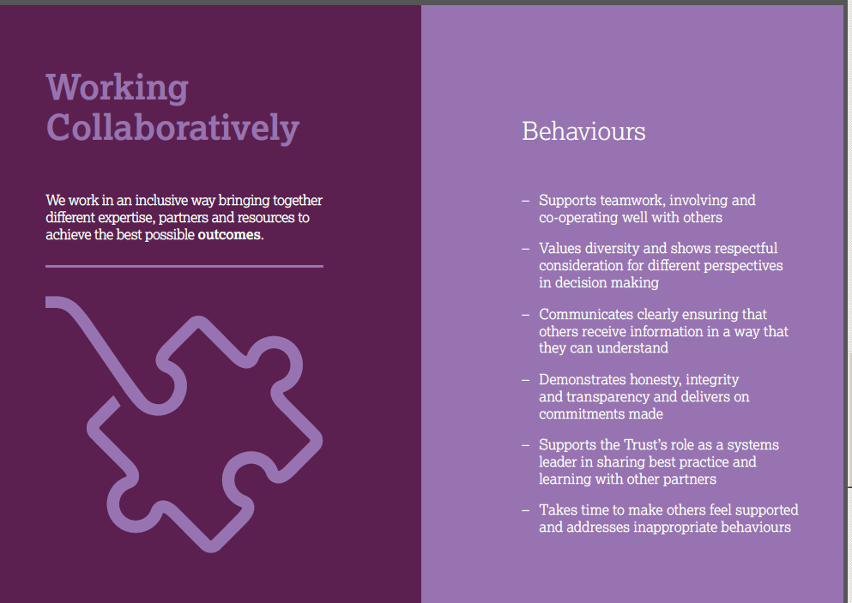

* The Joint Royal Marsden and ICR BME Staff Forum has increased its membership and planned a year of activity for 2018/19 to raise awareness of the forum and race equality issues across the Trust. This has included an open session with Yvonne Coghill, WRES Director; career journey conversations with senior BME leaders; a tropical summer party for all staff at both organisations, the launch of a book group and informal lunch time meetings.

# National and local benchmarking

The WRES findings are monitored nationally by the WRES Team, who produces an annual report to highlight areas of progress and good practice across the NHS and areas where further support and action is required. The national WRES report is based on the 2018 data findings across the NHS; however indicators 5 – 8 within this report are based on the 2017 findings.

London has the most diverse workforce with the 43.9% of all NHS trust stuff across the region being from a BME background, a 0.7% increase from 2017. Despite London trusts having the highest proportion of BME staff employed across the country, representation at senior pay bands is very low.

The likelihood of White staff being appointed from shortlisting compared to BME staff is greater in the London region (1.63 times more likely) than across England (1.45 times more likely), however this is an improvement. As London is the region with the highest proportion of the BME staff in its workforce and the highest proportion of BME people within its population, increased focus is required for this indicator across London.

Across the country, the relative likelihood of BME staff entering into the disciplinary process compared to White staff has reduced from 1.37 times more likely in 2017 to 1.24 times more likely in 2018. In the London region, BME staff are 1.77 times more likely to enter the formal disciplinary process compared with White staff. This is a small improvement on the previous year (1.80 times more likely). Findings from the Pan-London project to tackle this indicator will be used to identify further actions required.

The relative likelihood of White staff accessing non-mandatory training and CPD compared with BME staff has improved from 1.22 times more likely in 2017 to 1.15 times more likely in 2018 for the NHS and for the London region and now falls within the WRES definition of a non-adverse range of between 0.8 and 1.2.

The percentage of BME staff reporting harassment and bullying by patients remains the same as in 2017 (28.7%), however the percentage of BME staff reporting harassment and bullying by staff increased from 26.3% in 2016 to 27.8% in 2017. Across London the proportion of BME staff experiencing harassment and bullying by staff rose to 29.0% in 2016 to 29.9% in 2017.

The percentage of staff believing their trust provides equal opportunities for career promotion and progression fell from 75.5% in 2016 to 71.5% in 2017. This compares with 86.6% on White staff in 2017 compared with 88.0% in 2016. London was the worst performing region for this indicator with only 67.6% of BME staff and 84% of White staff believing their trust provides equal opportunities for career progression and promotion.

The proportion of BME staff that experienced discrimination in the last 12 months has increased from 13.8% to 15.0%, in contrast with 6.6% of White staff. In London the finding was worse with 16.3% of BME staff experiencing discrimination in the last 12 months which compares with 14.9% in 2016.

In 2019 the Trust scored better for indicators 5 – 8 for both BME staff and White staff compared with the average findings for the NHS and for the London region – see table 1 below.

**Table 1:2018 Trust findings for indicators 5 – 8 from the national staff survey compared with the 2017 average findings for the NHS and the London region**

|  |  |  |  |  |  |  |
| --- | --- | --- | --- | --- | --- | --- |
| **Indicator** | **RMH BME (2018)** | **RMH White (2018)** | **NHS BME (2017)** | **NHS White (2017)** | **London BME (2017)** | **London White (2017)** |
| Harassment and bullying by patients- indicator 5 | 18% | 18% | 29% | 28% | 40% | 32% |
| Harassment and bullying by staff - indicator 6 | 27% | 22% | 28% | 23% | 30% | 26% |
| Believing equal opportunities for career progression/ promotion - indicator 7 | 76% | 91% | 72% | 87% | 68% | 84% |
| Experiencing discrimination - indicator 8 | 12% | 5% | 15% | 7% | 16% | 8% |

From: NHS Workforce Race Equality Standard 2018 Data analysis report for NHS Trusts

7.4% of all Board members across the NHS are from a BME background which is significantly lower than the proportion of BME staff in the workforce overall (19.1%) but is an increase on previous years. 15.6% of London Board members are BME compared to 43.9% of the local London NHS workforce which is comparatively larger than other regions but us still a significant disparity between BME Board representation and the BME workforce population in London trusts.

# WRES conclusions

It is encouraging that there is improvement for the majority of the nine indicators since the WRES was launched in 2015, which reflects the organisations strategy to improve race equality through targeted actions and increased engagement with BME staff.

The strategies that are being taken to improve the experiences and outcomes for BME staff are multi-tiered and aim to have impact across all levels of the organisation. It is recognised that consistent monitoring of race equality performance with targeted actions has enabled improvements for the Trust. However there is still more to do to accelerate the improvement and an increased focus on ensuring proportionate ethnic representation particularly at senior level will be key to the change and is central to the WRES action plan for 2019 – 2020 outlined in section 6 below.

# WRES action plan 2019-2020

# The following actions are proposed for 2019- 2020 in order to maintain and improve the experiences and outcomes of BME staff within the Trust, as measured through the WRES. Actions have been taken directly from our Model Employer: Leadership Representation Strategy action plan which is monitored by the Workforce and Education Committee and Equality, Diversity and Inclusion Steering Group.

|  |  |  |  |  |
| --- | --- | --- | --- | --- |
| **2019/2020 WRES action plan** | | | | |
|  | **Outcome required** | **Action** | **Responsibility** | **Timescale** |
| 1 | Increased reporting to Board on equality metrics and progress | Six monthly report to Board | Director of Workforce | July 2019 |
| 2 | Wider sharing of workforce race equality data at Divisional level to build local awareness | Develop quarterly race equality data set to include Divisional workforce composition and recruitment data for leadership roles.  Provide race equality data through Divisional meetings. | Head of Resourcing/ HRBPs with Divisional Directors | From October 2019 |
| 3 | Plans in place to achieve workforce composition change required by 2028 | Recruitment targets to be developed for Divisions to attain year 1 workforce composition change required with focus on Nursing, Administration and Clerical and Healthcare Scientist staff groups.  Six monthly reporting to Workforce and Education Committee and EDI Steering Group | Divisional Directors with HRBPs/ Head of Resourcing | October 2019  From November 2019 |
| 4 | Conversations about race and inclusion are held across the organisation | Schwartz round on diversity and inclusion topic as part of the annual series of Schwartz rounds | Head of EDI/ Divisional Director Cancer Services | February 2020 |
| EDI Steering Group to host leadership race equality event in conjunction with the BAME staff forum | Head of EDI | October 2019 |
| 5 | Values are embedded into employment policy and practice and widely known across the organisation with team level understanding | Launch new appraisal and values based recruitment interview support for managers  Launch values content as part of induction programme  Team level discussions about impact of values for them | Asst Director Workforce Development/ Deputy Director of HR | From June 2019 |
| 6 | Recruitment panel members are diverse and have undertaken equality and diversity training | Quarterly monitoring of panel member training compliance and ethnic composition with candidate outcomes (for Band 8a and above vacancies) | Head of Resourcing/ Head of EDI | From September 2019 |
| 7 | Inclusive leadership to be integral part of all leadership development programmes | New programmes that are being procured require inclusive leadership to be a key component. | Asst Director Workforce Development | From June 2019 |

# Report approval

The Equality, Diversity and Inclusion Steering Group are asked to discuss and approve the 2019 WRES Report for formal publishing to meet WRES deadlines.

Appendix 1

## Summary of 2019 WRES findings (as at 31 March 2019)

|  |  |  |
| --- | --- | --- |
| Improvement | Similar findings | Deterioration |

## **Appendix 2: Indicator 1 – Percentage of staff in Agenda for Change pay bands, VSM and Medical and Dental grades 9as at 31 March 2019)**

|  |  |  |  |  |  |  |
| --- | --- | --- | --- | --- | --- | --- |
|  | **BME** | | **White** | | **Not stated** | |
| **Band 1** | 54 | 57.4% | 37 | 39.4% | 3 | 3.2% |
| **Band 2** | 72 | 32.1% | 147 | 65.6% | 5 | 2.2% |
| **Band 3** | 174 | 36.5% | 297 | 62.3% | 6 | 1.3% |
| **Band 4** | 146 | 34.9% | 268 | 64.1% | 4 | 1.0% |
| **Band 5** | 219 | 38.3% | 350 | 61.2% | 3 | 0.5% |
| **Band 6** | 331 | 36.3% | 569 | 62.3% | 13 | 1.4% |
| **Band 7** | 182 | 25.8% | 516 | 73.1% | 8 | 1.1% |
| **Band 8A and above** | 91 | 21.3% | 407 | 77.2% | 4 | 1.5% |
| **Medical & Dental Consultant** | 60 | 30.9% | 124 | 63.9% | 10 | 5.2% |
| **Medical & Dental Non-consultant career grade** | 9 | 45.0% | 11 | 55.0% | 0 | 0.0% |
| **Medical & Dental Trainee grades** | 81 | 35.2% | 135 | 58.7% | 14 | 6.1% |
| **Total** | **1419** | **32.6%** | **2861** | **65.8%** | **70** | **1.6%** |